PROBLEM & BACKGROUND

Toronto and New York are the famous places in North America. They are diverse in many ways. Both are multicultural as well as the financial hubs of their respective countries. The purpose of this project is to explore how much they are similar or dissimilar in aspects from a tourist point of view regarding food, accommodation, beautiful places, and many more.

Today Tourism is one of the pillars of the economy and the people most often visits those countries who are rich in heritage and developed enough from a foreign prospective, like friendly environment. Every city is unique in their own way and give something new. And now the information is so common regarding location of every place around the world on your fingertips which make it easier to explore. Therefore, tourists always eager to travel to different places on the basis of available information, and the comparison (the part of the information) between the two cities always assist to choose the specific places or according to their choice.

# DATA DESCRIPTION

### For this problem, Foursquare API service is used to explore the data of two cities, in terms of their neighborhoods. The data also include the information about the places around each neighborhood like restaurants, hotels, coffee shops, parks, theaters, art galleries, museums and many more. We selected one Borough from each city to analyze their neighborhoods. Manhattan from New York and Downtown Toronto from Toronto. These objects will be given priority on the basis of foot traffic (activity) in their respective neighborhoods. This will help to locate the tourist’s areas and hubs, and then we can judge the similarity or dissimilarity between two cities on that basis.

# METHODOLOGY

# The Borough of the two cities were selected to explore their neighborhoods. The data exploration, analysis and visualization for both boroughs are done in the same way but separately.

# EXPLORATION

# For Downtown Toronto case, The table was extracted of Toronto’s Borough from Wikipedia page('https://en.wikipedia.org/wiki/List_of_postal_codes_of_Canada:_M'). And then the data was arranged based on the requirement. In the arrangement phase, which applied multiple steps including but not limited to, eliminating “Not assigned” values, combine neighborhoods which have same geographical coordinates at each borough and sorted against the concerned borough. For data verification and further exploration, a Foursquare API was used to get the coordinates of Downtown Toronto and explore its neighborhoods. The neighborhoods are further characterized as venues and venue categories.

# For Manhattan, <https://geo.nyu.edu/catalog/nyu_2451_34572> was used a saved data file which is already explored through foursquare API in which we have extracted all the boroughs of New York and then sorted against the concerned borough. Then we explored the Manhattan neighborhoods as venues and venue categories

### 

### 

### Toronto, Canada

### 

### Manhattan

### 

#### Transform the data into a *pandas* dataframe

The next task is essentially transforming this data of nested Python dictionaries into a pandas dataframe. So let's start by creating an empty dataframe.

New York City

### 

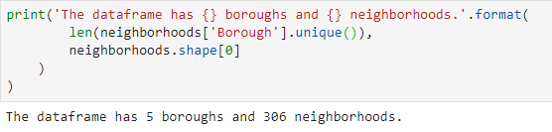

**Foursquare API**

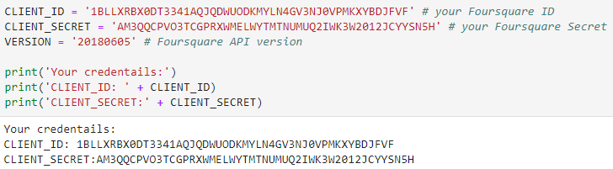

# ANALYSIS

### The boroughs and neighborhoods was analyzed through one hot encoding (giving ‘1’ if a venue category is there, and ‘0’ in case of venue category is not there). On the basis of one hot encoding, we calculate mean of the frequency of occurrence of each category and picked top ten venues on that basis for each neighborhood. It means the top venues are showing the foot traffic or the more visited places.

## **Exploring Neighborhoods in Downtown Toronto**

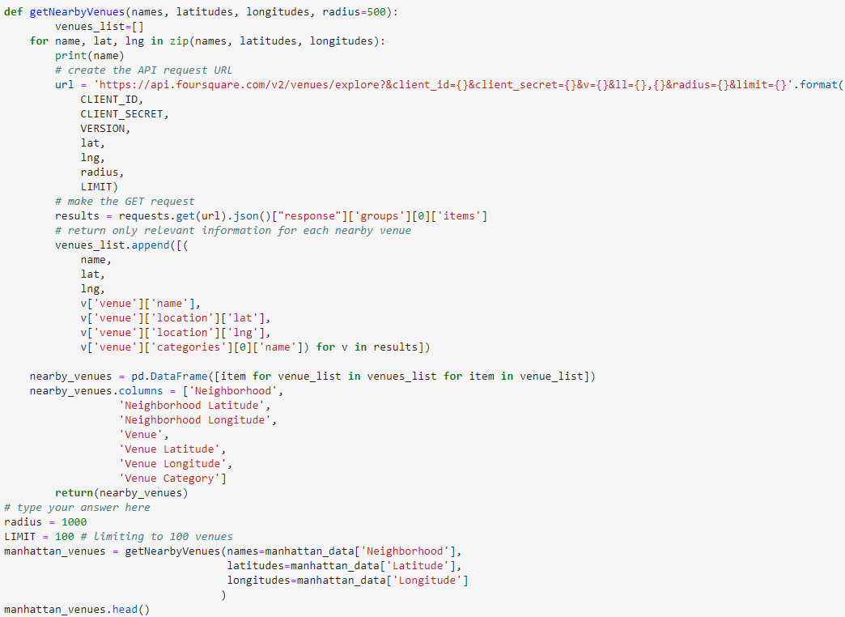

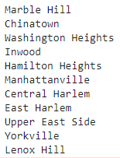

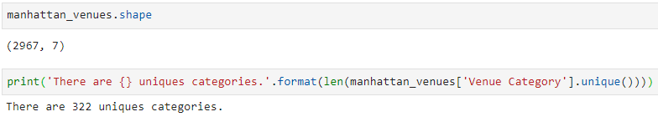

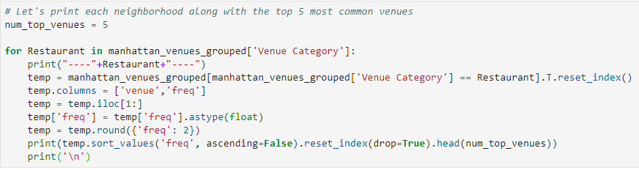

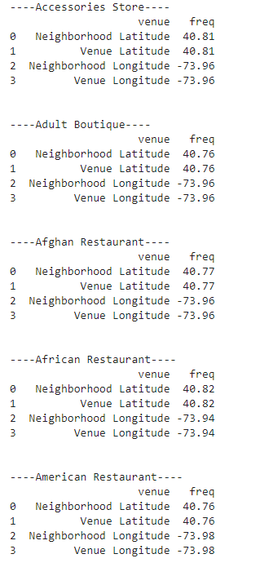

## **Exploring Neighborhoods in Downtown Toronto**

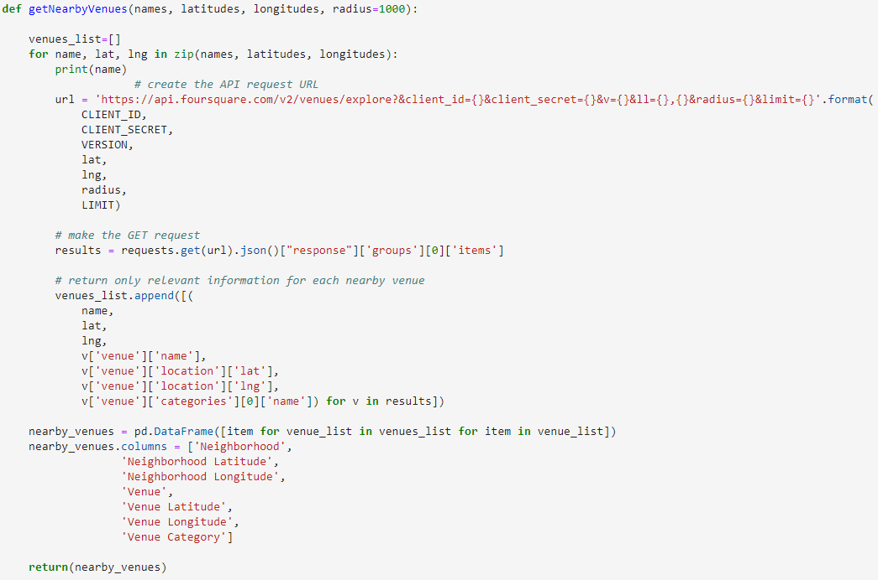

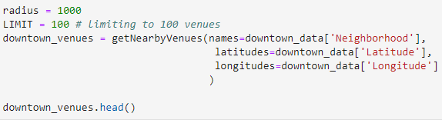

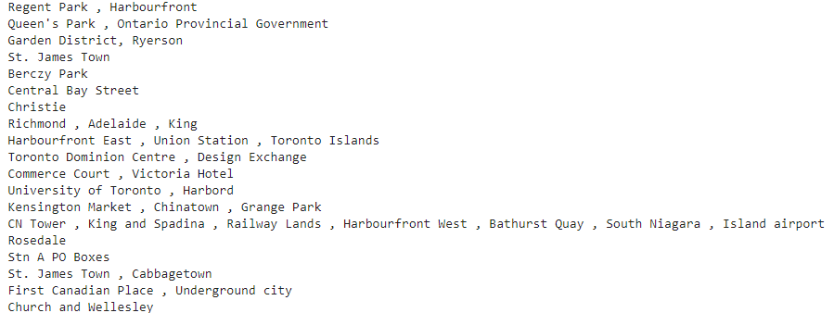

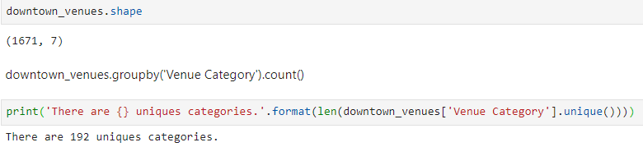

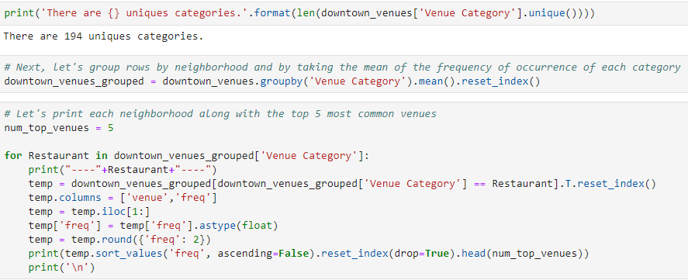

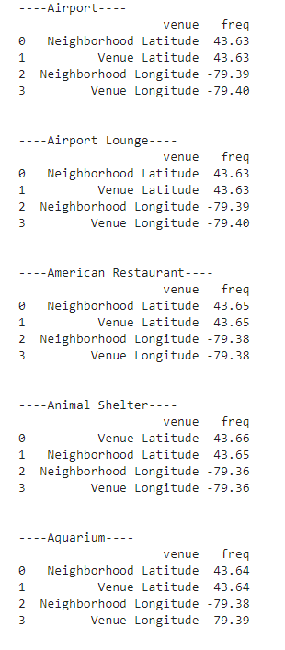

# VISUALIZATION

**Downtown, CA**

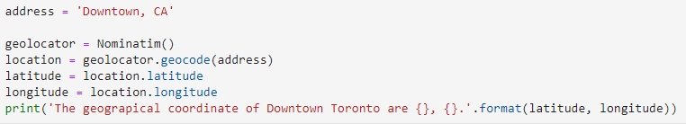



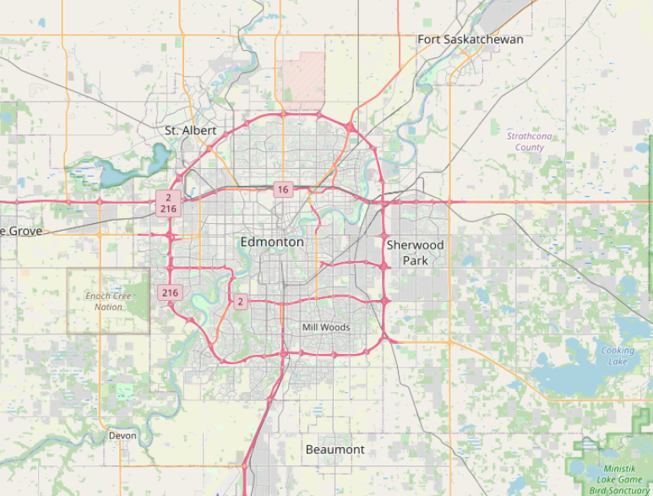

**Manhattan, NY**

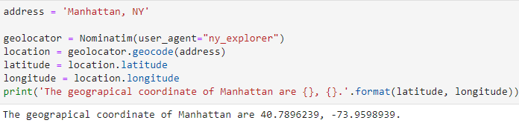

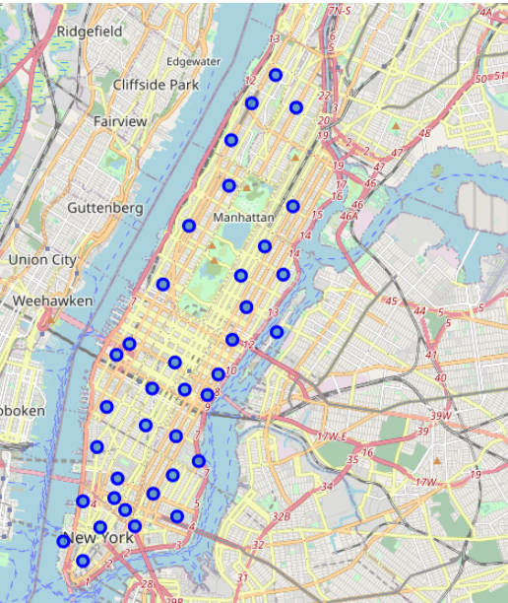

Conclusion

* Based on the number of neighborhoods and brought Analysis Manhattan has 2967 Neighborhoods and 7 Borough with 322 unique categories whereas Toronto has 1671 Neighborhoods and 7 Borough & 194 Unique categories.

### Recommendation

* Based the number of unique Categories Manhattan has a lot of places to visit than Toronto. SO I recommend for the Tourist to visit this place and in order to be exposed with various new things they haven’t exposed before.